- Write in a standard form
  - $0. 003 12$ b. $2 400 000$

- Write as a number
  - $3.5×{10}^{6}$ b. $3.9×{10}^{-4}$
- Give your answers in standard form
$a. \left(9×{10}^{500}\right)×\left(7×{10}^{-200}\right)$ b. $\left(3×{10}^{-600}\right)÷\left(1.2×{10}^{100}\right)$
- Give your answers in standard form
$a. \left(4.1×{10}^{200}\right)+\left(2.3×{10}^{201}\right)$ b. $\left(5.1×{10}^{-300}\right)-\left(3.7×{10}^{-302}\right)$
- Solve the following inequality and show the answers on a number line.
$4\left(x+4\right)<5\left(2x-1\right)≤7x+10$
- Solve the following equations
- $3x^{2}-7=5$ b. $\sqrt{7+x}+5=9$
- Add the following algebraic fractions
  - $\frac{x+3}{6}-\frac{x+3y}{4}-\frac{5x-y}{8}$ b. $\frac{1}{3a}+\frac{2}{9b}-\frac{5}{6ab}$
- Simplify the following algebraic fractions
  - $\frac{5x^{4}y^{2}}{\sqrt{{9x}^{8}}}×\frac{(6x{y)}^{3}}{20xy^{3}}$ b. $\frac{3x^{3}y^{2}}{x\sqrt{y^{4}}}÷\frac{9x^{4}y}{(2{x)}^{3}}$
- Simplify the following algebraic fractions
  - $\frac{5x^{4}y^{3}-15yx^{2}}{30xy^{2}}$ b. $\frac{3x^{2}y^{3}+15xy^{4}}{4xy+20y^{2}}$
- Find the equation of the line on the diagram below
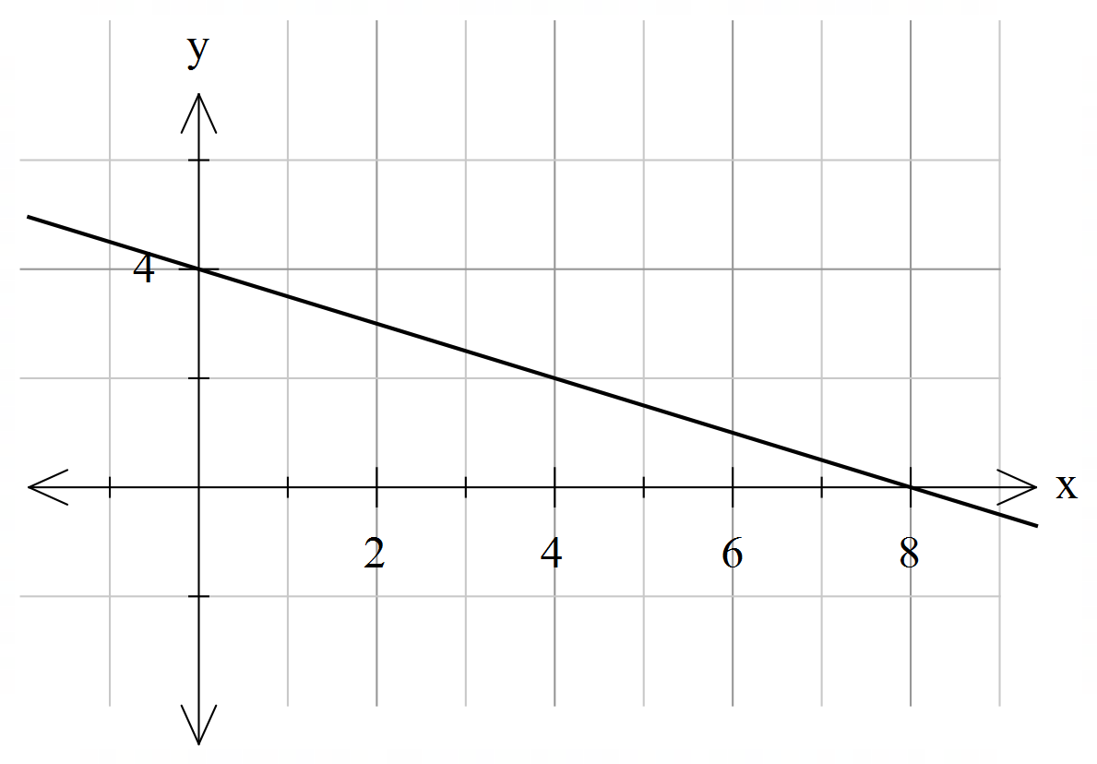
- Gradient of line passing through the points $(-2, 3)$ and $\left(5, b\right)$is 4. Find the value of $b$.
- Find the gradient and $y-$intercept of the line $3y-2x=24$.
- Find equation of line parallel to line $y=-\frac{2}{5}x+3 ,$ and passing through point $(2, -5)$.
- a. Find the $x-$ and $y-$intercepts of line $3y-5x=30$.
b. Hence sketch the line.
- a. Draw lines $y=\frac{1}{2}x-3$ and $y=-4x+6$ on the same set of axes: 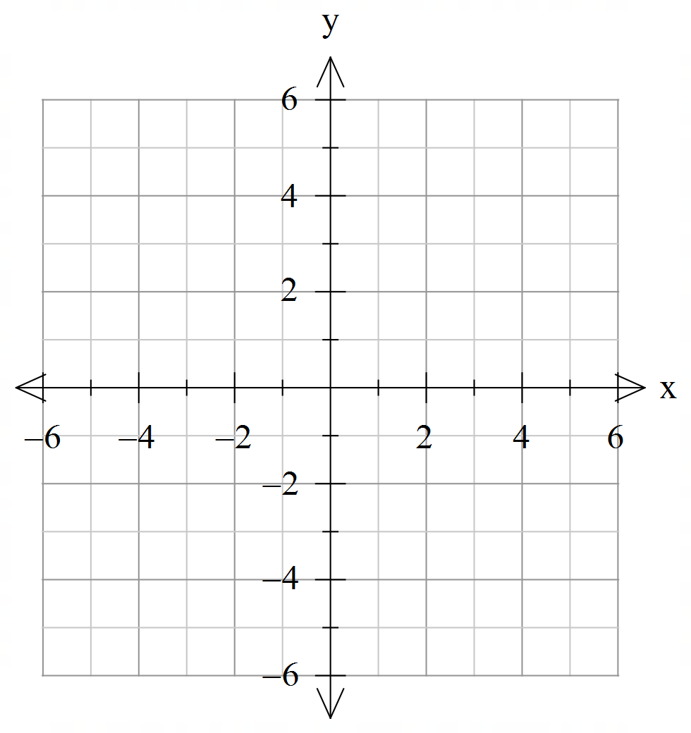
- Hence solve simultaneous equations graphically, using your graph.
$$y=\frac{1}{2}x-3$$
$$y=-4x+6$$
- M is the midpoint of AB and Triangle BCX is isosceles. Find perimeter of triangle ABC.
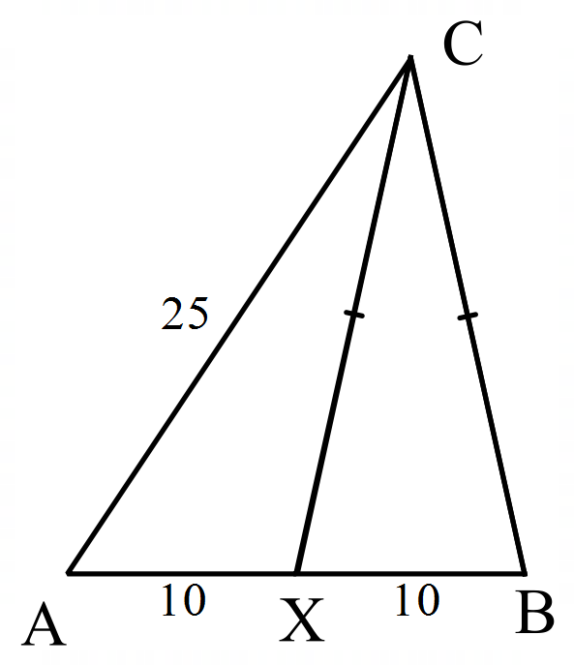

- Find the angle $x$, clearly state the reasoning.
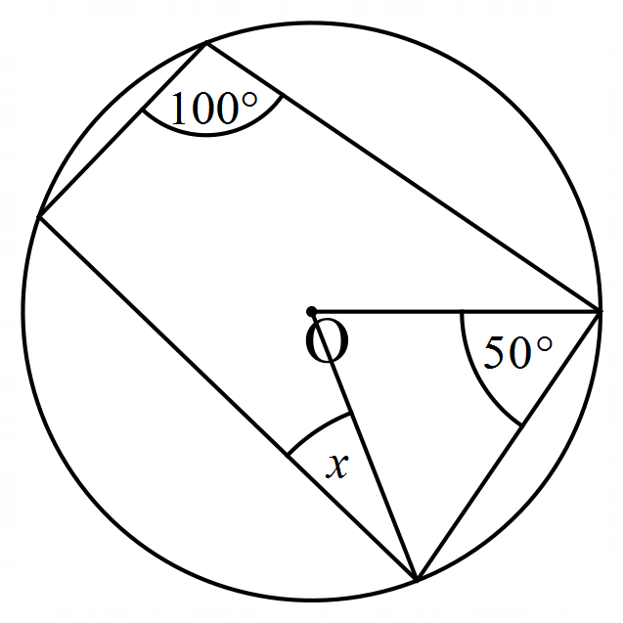
- Solve the following equations
  - $\frac{4x-1}{6}-\frac{x-6}{12}=\frac{2x+1}{3}$ b. $\frac{x}{x+3}-\frac{1}{2}=7$
- Solve the following simultaneous equations.

$2x+5y=3$ $2x+3y=11$
$y+x=0$ $5x-4y=7$

